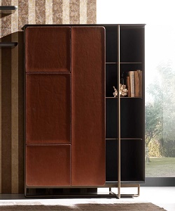

Rosewood cupboard

$150.32

Availability: In stock

Description

Modern wood single sliding door with many sections. With its curvaceous contour surface, this will gives a fashionable look to your room. The nature and design of this allows it to suit most modern bedrooms.